

**ZARQA UNIVERSITY – FACULTY OF INFORMATION TECHNOLOGY**

**DEPARTMENT *COMPUTER SCIENCE***

**Image Style Transfer Using Convolutional Neural Networks**

A graduation project document submitted to the Dept. of Computer Science as partial fulfillment for the Requirement for the Degree of B.Sc. in Computer Science

**By**

**Abdulrahman Mahmoud Yaghmour**

**Ammar Abdulrahman Alsharif**

**Supervised by**

**Prof. Essam Al Daoud**

**COMMITTEE REPORT**

**We certify that we have read this graduation project report as examining committee, examined the student in its content and that in our opinion it is adequate as a project document for B.Sc. in *By Specialty.***

|  |  |
| --- | --- |
| **Chairman:** | **Committee member:** |
| **Name: ………………………………** | **Name: ………………………………** |
| **Signature: …………………….……** | **Signature: …………………….……** |
| **Date: ……/……/……………………** | **Date: ……/……/……………………** |
|  |  |
| **Supervisor:** |  |
| **Name: ………………………………** |  |
| **Signature: …………………….……** |  |
| **Date: ……/……/……………………** |  |

To my parents

and my family

who made this accomplishment possible.

**الشكر**

الحمد لله الذي لا تتم النعم إلا بفضله وأصلي وأسلم على من لا نبي بعده.

أولاً أحب أن أشكر عائلتي ، وخاصةً نبع الحنان والرعاية والتوجيه والدتي العزيزة وموجهي ونبراسي في حياتي والدي الفاضل لما قدموه لي من التشجيع والصبر والمساعدة على مر السنين. فأنا مدين لهم إلى الأبد واسأل الله العظيم أن يمد في عمري حتى أتمكن من برهما.

وأقدم جزيل الشكر والامتنان لمشرفي الفاضل الأستاذ الدكتور عصام الداوود على ما قدمه من دعم وتوجيه وتشجيع مميز طوال فترة العمل في المشروع . والذي بدورة افضى الى هذا الانجاز الذي اعتز وافتخر به . وأود ايضا ان اعرب عن امتناني وتقديري الكبير للجنة المناقشة الفاضلة على الملاحظات المفيدة والدقيقة . واشكر كذلك كلية تكنولوجيا المعلومات ممثلة بكافة اعضاء الهيئة التدريسية دون استثناء والإداريين ومشرفي المختبرات لما وفروه لي من دعم وإرشاد اكاديمي ومعنوي كان له الاثر البارز في هذا الجهد. وكذلك لا انسى جامعتي العزيزة التي اعتز بانتمائي لها عبر هذه الفترة الحاسمة والمهمة من حياتي والتي قضيتها في ربوعها.

* زملائي وأصدقائي كل الشكر لكم ايضا .

contents

CHAPTER ONE INTRODUCTION 9

1.1 Introduction 10

1.2 Problem Definition: 11

1.3 Objective: 11

1.4 Related Work: 11

1.4.1 Introduction: 11

1.4.2 A Neural Algorithm of Artistic Style: 11

1.4.3 Universal Style Transfer via Feature Transforms: 11

1.4.4 Arbitrary Style Transfer in Real-time with Adaptive Instance Normalization: 12

1.5 Development Tools: 12

1.5.1 Python: 12

1.5.2 Keras: 13

1.5.3 TensorFlow: 13

1.5.4 NumPy: 13

1.5.5 COCO Dataset: 13

1.5.6 VGG16: 13

CHAPTER TWO METHOD 14

2.1 General Overview: 15

2.2 Model details: 16

2.2.1 Feature Extraction Network $∅$ (VGG16 Net): 17

2.2.1.1 VGG Model [5]: 17

2.2.1.2 Content Representation: 18

2.2.1.3 Style Representation: 18

2.2.2 Loss Functions: 19

2.2.2.1 Feature Reconstruction Loss: 19

2.2.2.2 Style Reconstruction Loss: 19

2.2.2.3 Total Variation Loss: 20

2.2.2.4 Global Loss: 20

2.2.3 Image Transformation Network: 21

Residual Connections: 22

2.3 Training Details: 22

2.3.1 Dataset: 22

2.3.2 Training: 23

2.4 Codes: 24

CHAPTER THREE EXPERIMENTS AND RESULT 27

3.1 Introduction: 28

3.2 Experiments: 28

3.3 Results: 30

REFERENCES: 32

**LIST OF FIGURES**

Figure ‎2‑1: System overview. 16

Figure ‎2‑2: VGG Model architecture that we used for feature extraction. 17

Figure ‎2‑3: architecture used for style transfer network. 21

Figure ‎2‑4: Convolutional Residual Block. 22

Figure ‎2‑5: Example of classification, segmentation and localization. 23

Figure ‎2‑6: Transformation Network 24

Figure ‎2‑7: Gram Matrix & Style Reconstruction Loss 25

Figure ‎2‑8: Feature & TV Losses 25

Figure ‎2‑9: Methods to Add the Losses to the Model 26

Figure ‎2‑10: Declare & Initialize the Model 26

Figure ‎3‑1: Output at different layers of the feature extraction network 29

Figure ‎3‑2: Stylized Images Generated by our Model (1) 30

Figure ‎3‑3: Stylized Images Generated by our Model (2) 31

**LIST OF EQUATIONS**

Equation ‎2‑1: inner product between vectorized feature maps 19

Equation ‎2‑2: feature reconstruction loss 19

Equation ‎2‑3: gram matrix elements 19

Equation ‎2‑4: gram matrix elements (vectorized implementation) 20

Equation ‎2‑5: style reconstruction loss 20

Equation ‎2‑6: sum of all style reconstrucion losses 20

Equation ‎2‑7: tv variation loss 20

Equation ‎2‑8: global loss 20

**Abstract**

Why do humans create art? Psychologically speaking, we do it for a few reasons, to evoke an emotional response, to recall past events and emotions, to communicate, and to educate, Art is something human create to understand who they are. With earlier technologies, art has existed in a complex, and continually evolving relationship with the technological capabilities, those capabilities constrain the art that is produced by this technology, and the way art is perceived and understood by its audience. With today technologies, AI played a major role emulating some human skills in fine art, especially painting, we use AI to create art by first teaching the machine to understand and replicate our own art. The technique is called style transfer.

Q: Have you ever wish you could paint like Picasso or Van Gogh?

Here we introduce an artificial system based on a Deep Neural Network that creates artistic images of high perceptual quality, Neural style transfer is an optimization technique used to take two images, a content image, a style reference image (such as an artwork by a famous painter)  and blend them together such that the input image is transformed to look like the content image, but “painted” in the style of the style image, Were the magic in the art pieces can move to transform image.

**الخلاصة**

لماذا يمارس البشر الفن , لماذا يؤدونه ويبرعون فيه؟

أجاب على هذا التساؤل علم النفس حيث كانت الاجابة بأن البشر يمارسونه لاسباب معينة وهي انطلاقا من حاجة عاطفية لوصف أحداث سابقة، ووصف مشاعرنا، و للتواصل وللتثقيف، مهمة الاعمال الفنية أن ترسخ تلك الافكار في عقل الافراد وتزودهم بالايحاءات المناسبة لفهم الاحداث.

مع بدايات ظهور التكنولوجيا كان للفن تواجد لكن بطريقة متواضعة و محدودة وذالك باستخدام الطرق الكلاسكية مثل معالجة الصور الرقمية العادية او برامج الرسم على الحاسوب وهذه الادوات العادية لم تعطي للفن حقه مثال محاكاه الكثير من اللوحات العالمية لفنانين عالمين مثل بيكاسو وفان جوخ والكثير من الفنانين الذين كانو يتبعون انماطا مميزة من الرسم، عجزت الطرق الحاسوبية التقليدية عن محاكاتها، لذالك خلقت تلك الطرق الكلاسيكية محددات قيدت الفن الذي يمثل على الحاسوب وقيدت طريقة عرضه للجمهور. مع تقنيات اليوم ، لعب الذكاء الاصناعي دورا رئيسيا لمحاكاة بعض المهارات البشرية في الفنون الجميلة، وخاصة الرسم، يستخدم الذكاء الاصطناعي لصنع الفن من خلال تعليم الآلة ,لفهم وتكرار أعمالنا الفنية. هذه التقنية تسمى Image Style Transfer.

س: هل سبق لك أن شعرت برغبة قوية بأن ترسم مثل بيكاسو أو فان جوخ؟

هنا نقدم لك نظام يعمل بالذكاء الاصطناعي ليحقق لك تلك الرغبة بانشاء صور فنية ذات جودة عالية وذالك من خلال ادخال صورتين الى النظام الأولى صورة المحتوى وهي صورة عادية التقطت بكاميرا الموبايل و الثانية صورة الستايل وهي الصورة المرجعية(صورة لاي لوحة اخذت من عمل فني) وهي عادة تكون صورة تحتوي على نمط مميز ثم من خلال النظام يتم مزجهما معا بحيث يتم اصدار صورة جديدة هي نفس صورة المحتوى التي أدخلت للنظام لكنها قد رسمت بنفس نمط صورة الستايل وتتحول الى عمل فني ساحر.

# CHAPTER ONE INTRODUCTION

## Introduction

Among the applications of Convolutional Neural Networks (CNN) and visual recognition, style transfer has been a very heated topic. Style transfer is the technique of separating and recombining the content and the style of an arbitrary image. The topic is particularly interesting because it creates artificial intelligence that inter-plays the content and the style of an image to produce artistic results of high quality. The problem used to be difficult because it was hard to extract texture information using conventional computer vision techniques. With the advent of CNNs, we are able to tackle the problem in a more sophisticated manner.

The first major step in this field was introduced in the paper [**A Neural Algorithm of Artistic Style**](https://arxiv.org/abs/1508.06576) in September 2015. Gatys et. al[1] show that the task of transferring the style from one image to the content of another can be posed as an optimization problem which can be solved using gradient descent.

In March 2016 a group of researchers from Stanford University published a paper which outlined a method for achieving real-time style transfer. They were able to train a neural network to apply a single style to any given content image. Given this ability, a different network could be trained for each different style we wish to apply. The paper, titled [**Perceptual Losses for Real-Time Style Transfer and Super-Resolution**](https://arxiv.org/abs/1603.08155) by Johnson et. al[2], shows that it is possible to train a neural network to apply a single style to any given content image with a single forward pass through the network.

In this project we’ll explain and implement the method they proposed and share some results we obtained.

## Problem Definition:

One of the drawbacks of the first method that was solved the style transfer problem is the long time taken to generate stylized images. For each style transfer that we want to generate we need to solve a new optimization problem which will take again a long time to be done.

## Objective:

In our system for one style we train a transformation network to solve the optimization problem for one time, after that the trained network corresponding to selected style images are capable of performing style transfer for any content image with a single forward pass achieving as high 1000X speedup and similar qualitative result as Gatys et al [1].

## Related Work:

### Introduction:

Several research works have been developed around the world to solve the style transfer problem, we highlight the ones mentioned below:

### A Neural Algorithm of Artistic Style:

Gatys et al. [1] first studied how to use a CNN to reproduce famous painting styles on natural images. They proposed to model the content of a photo as the feature responses from a pre-trained CNN, and further model the style of an artwork as the summary feature statistics. Their experimental results demonstrated that a CNN is capable of extracting content information from an arbitrary photograph and style information from a well-known artwork. Based on this finding, Gatys et al. [1] first proposed to exploit CNN feature activations to recombine the content of a given photo and the style of famous artworks. The key idea behind their algorithm is to iteratively optimize an image with the objective of matching desired CNN feature distributions, which involves both the photo’s content information and artwork’s style information. Their proposed algorithm successfully produces stylized images with the appearance of a given artwork.

### Universal Style Transfer via Feature Transforms:

Universal style transfer paper [3] aims to transfer arbitrary visual styles to content images. Existing feed-forward based methods, while enjoying the inference efficiency, are mainly limited by inability of generalizing to unseen styles or compromised visual quality. In this paper, they present a simple yet effective method that tackles these limitations without training on any pre-defined styles. The key ingredient of their method is a pair of feature transforms, whitening and coloring, that are embedded to an image reconstruction network. The whitening and coloring transforms reflect a direct matching of feature covariance of the content image to a given style image, which shares similar spirits with the optimization of Gram matrix-based cost in neural style transfer. they demonstrate the effectiveness of their algorithm by generating high-quality stylized images with comparisons to a number of recent methods. They also analyze their method by visualizing the whitened features and synthesizing textures via simple feature coloring.

### Arbitrary Style Transfer in Real-time with Adaptive Instance Normalization:

In this paper [4], they present a simple yet effective approach that for the first time enables arbitrary style transfer in real-time. At the heart of their method is a novel adaptive instance normalization (AdaIN) layer that aligns the mean and variance of the content features with those of the style features. Their method achieves speed comparable to the fastest existing approach, without the restriction to a pre-defined set of styles. In addition, their approach allows flexible user controls such as content-style trade-off, style interpolation, color & spatial controls, all using a single feed-forward neural network.

## Development Tools:

### Python:

Python is an interpreted, high-level, general-purpose programming language. It is a very powerful tool, which is also open sourced and flexible. It is known to have massive libraries for manipulation of data and is extremely easy to learn, Python code is often said to be almost like pseudocode, since it allows you to express very powerful ideas in very few lines of code while being very readable. And There are a lot of deep learning frameworks in Python such as Keras, TensorFlow, PyTorch, Caffe … etc. You can pick from many free tools, which will fit your project, allowing you to build deep learning architectures with remarkably few lines of Python code.

### Keras:

Keras is a high-level neural networks API, written in Python and capable of running on top of TensorFlow, CNTK, or Theano. Designed to enable fast experimentation with deep neural networks, it focuses on being user-friendly, modular, and extensible. Being able to go from idea to result with the least possible delay is key to doing good research. Keras is our project main deep learning framework.

### TensorFlow:

TensorFlow™ is an open source software library for high performance numerical computation. Its flexible architecture allows easy deployment of computation across a variety of platforms (CPUs, GPUs, TPUs), and from desktops to clusters of servers to mobile and edge devices. Originally developed by researchers and engineers from the Google Brain team within Google’s AI organization, it comes with strong support for machine learning and deep learning and, the flexible numerical computation core is used across many other scientific domains. And in our project TensorFlow serving as the backend engine of Keras.

### NumPy:

NumPy is the core library for scientific computing in Python, adding support for large, multi-dimensional arrays and matrices, along with a large collection of high-level mathematical functions to operate on these arrays.

### COCO Dataset:

COCO stands for Common Objects in Context. it is a large-scale object detection, segmentation, and captioning dataset with 330K images and 80 object categories. As hinted by the name, images in COCO dataset are taken from everyday scenes thus attaching “context” to the objects captured in the scenes.

### VGG16:

VGG is a convolutional neural network model proposed by *K. Simonyan and A. Zisserman* from the University of Oxford in the paper **“Very Deep Convolutional Networks for Large-Scale Image Recognition”** [5], with 16 layers of CNN and Artificial Neural Network (ANN), involving 138 million parameters. The model achieves 92.7% top-5 test accuracy in ImageNet, which is a dataset of over 14 million images belonging to 21k categories.

# CHAPTER TWO METHOD

## General Overview:

In General, our method is divided into two processes, first one is to train the model on a given style image and second one is to apply the style to any given image in only one forward pass.

**In the First process we use two neural networks:**

1. Image Transformation Network: which is a Convolutional Neural Network that takes an input image ($x$) and transforms it to the output stylized image(ŷ).
2. High Level Feature Extraction Network: which is used to extract the style and content representation from a given image, in this part we use the VGG16 model which we will talk about later in this chapter.

The training process is made on the Microsoft COCO dataset (Common Objects in Context) Dataset that is an excellent object detection dataset with 80 classes, 80,000 training images and 40,000 validation images.

* The Training process is done as follows:

1. Give an image (content image) from the COCO dataset to the Image Transformation Network to get the generated image.
2. Give the generated image to the VGG16 Net to get its content and style representations.
3. Give the same image (content image) that was given in the first step from COCO dataset to VGG16 Net also to get its content and style representations.
4. Compute the style loss function between the style representation of the generated image and the content image.
5. Compute the content loss function between the content representation of the generated image and the content image.
6. Compute the global loss function which is the weighted sum of the previous two losses.
7. Updates the weights of Image Transformation Network with respect to the global loss function.
8. Repeats these steps (1 🡪 7) on the whole dataset until the style transfer process is done very well which means the global loss is minimized.

**The second process (Feed-Forward Process):**

* In this process we need to use the Image Transformation Network only. After the training process the Transformation Network weights that we get will represent the style of the given style image, So to apply this style to any image we can simply do that by loading the weights to the Transformation Network and give it the image that we want to apply the style on, then the stylized image will be generated by only one forward pass.

## Model details:

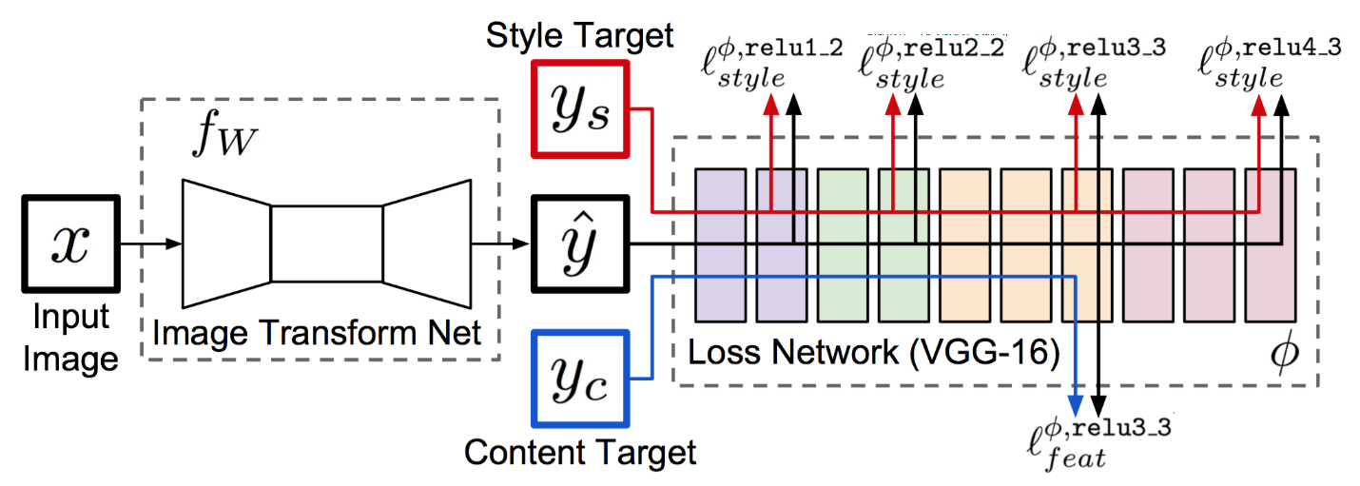

Figure ‎2‑1: System overview. We train an image transformation network to transform input images into output images. We use a feature extraction network (loss network) pretrained for image classification to define perceptual loss functions that measure perceptual differences in content and style between images. The feature extraction network remains fixed during the training process.

As shown in **Fig. 2-1**, our system consists of two components:

An *image transformation network* ($fw$) and a *feature extraction network* ($∅$) that is used to define several loss functions $l_{1 }, . . . ,l_{k}$. The image transformation network is a deep residual convolutional neural network parameterized by weights $W$, it transforms input image $x$ into output images $\hat{y}$ via the mapping $\hat{y}=fw(x)$. Each loss function computes a scalar value $l_{i}(\hat{y},y_{i})$ measuring the difference between the output image $\hat{y}$ and a target image $y_{i}$. The image transformation network is trained using stochastic gradient descent to minimize a weighted combination of loss functions.

### Feature Extraction Network $∅$ (VGG16 Net):

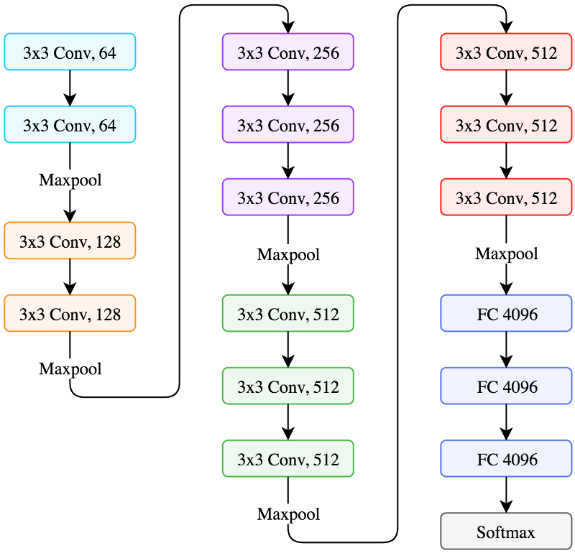

Figure ‎2‑2: VGG Model architecture that we used for feature extraction.

#### **VGG Model** [5]:

It is a convolutional neural network from researchers at Oxford’s Visual Geometry Group, hence the name VGG. It was the runner up of the ImageNet classification challenge with 7.3% error rate. Where I[mageNet](http://www.image-net.org/) is the most comprehensive hand-annotated visual dataset, and they hold competitions every year where researchers from all around the world compete. All the famous CNN architectures make their debut at that competition. VGG is a 16-layer neural net. It’s also referred to as VGG16. The architecture is the one we worked with above **Fig. 2-2**. Stacked convolution + pooling layers followed by fully connected ANN. A few observations about the VGG16 architecture:

* It only uses 3x3 convolutions throughout the network with lots of filters.
* Trained on 4 GPUs for 3 weeks.
* It is currently the most preferred choice in the community for extracting features from images.
* The weight configuration of the VGG16 Net is publicly available and has been used in many other applications and challenges as a baseline feature extractor.
* VGG16 Net consists of 138 million parameters, which can be a bit challenging to handle.
* It has already learned to encode the perceptual and semantic information we would like to measure in our loss functions.

So, we make use of a network $∅$ which has been pretrained for image classification as a fixed *feature extraction network* in order to define our loss functions.

The *feature extraction network $∅$* is used to define a *feature reconstruction loss $l_{feat}^{∅}$*  and a *style reconstruction loss $l_{style}^{∅}$*  that measure differences in content and style between images. For each input image $x$, we have a *content target $y_{c}$*  and a *style target $y_{s}$* . For style transfer, the content target $y_{c}$ is the input image $x$ and the output image $\hat{y}$ should combine the content of $x = y_{c}$ with the style of $y_{s}$.

#### Content Representation:

Generally, each layer in the network defines a non-linear filter bank whose complexity increases with the position of the layer in the network. Hence a given input image $x$ is encoded in each layer of the Convolutional Neural Network by the filter responses to that image. A layer $j$ with $C_{j}$ distinct filters has $C_{j}$ feature maps each of size $H_{j} × W_{j}$, where $H_{j}$ is the height and $W_{j}$ is the width of the feature map. When Convolutional Neural Networks are trained on object recognition, they develop a representation of the image that makes object information increasingly explicit along the processing hierarchy. Therefore, along the processing hierarchy of the network, the input image is transformed into representations that are increasingly sensitive to the actual content of the image but become relatively invariant to its precise appearance. Thus, higher layers in the network capture the high-level content in terms of objects and their arrangement in the input image but do not constrain the exact pixel values of the reconstruction very much. In contrast, reconstructions from the lower layers simply reproduce the exact pixel values of the original image. We therefore refer to the feature responses in higher layers of the network as the *content representation*.

#### Style Representation:

To obtain a representation of the style of an input image, we use a feature space designed to capture texture information [6]. This feature space can be built on top of the filter responses in any layer of the network. It consists of the correlations between the different filter responses, where the expectation is taken over the spatial extent of the feature maps. These feature correlations are given by the Gram matrix. Let $F_{ij}^{l}$ is the activation of the $i^{th}$ filter at position $j$ in layer $l$, and $C^{l}$ is the number of feature maps produced by the layer $l$, Then the Gram Matrix $G^{l}∈R^{C_{l} × C_{l}}$, where $G_{ij}^{l}$ is the inner product between the vectorized feature maps $i$ and $j$ in layer $l$:

$G_{ij}^{l}= \sum_{k}{F_{ik}^{l}F_{jk}^{l}}$ (Equation ‎2‑1)

By including the feature correlations of multiple layers, we obtain a stationary, multi-scale representation of the input image, which captures its texture information.

### Loss Functions:

#### **Feature Reconstruction Loss:**

Rather than encouraging the pixels of the output image $\hat{y}=fw(x)$ to exactly match the pixels of the target image $y$, we instead encourage them to have similar feature representations as computed by the *feature extraction network $∅$* . Let $∅_{j}(x)$ be the activations of the $j^{th}$ layer of the network $∅$ when processing the image $x$, if $j$ is a convolutional layer then $∅_{j}(x)$ will be a feature map of shape $C_{j}× H_{j} × W_{j}$. The *feature reconstruction loss* is the (squared, normalized) Euclidean distance between feature representations:

$l_{feat}^{∅,j}\left(\hat{y},y\right)= \frac{1}{C_{j}H_{j}W_{j}}\left\|∅_{j}\left(\hat{y}\right)- ∅_{j}\left(y\right)\right\|\begin{matrix}2 \\ 2\end{matrix}$ (Equation ‎2‑2)

By a feature reconstruction loss for training our image transformation networks encourages the output image $\hat{y}$ to be perceptually similar to the target image $y$, but does not force them to match exactly.

#### **Style Reconstruction Loss:**

The *feature reconstruction loss* penalizes the output image $\hat{y}$ when it deviates in content from the target y. We also wish to penalize differences in style: colors, textures, common patterns, etc. To achieve this effect, Gatys et al [1,6] propose the following *style reconstruction loss*. As above, let $∅_{j}(x)$ be the activations at the $j^{th}$ layer of the network $∅$ for the input $x$, which is a feature map of shape $C_{j}× H_{j} × W_{j}$. Define the *Gram matrix $G_{j}^{∅}(x)$* to be the $C_{j}× C_{j}$ matrix whose elements are given by:

${G_{j}^{∅}(x)}_{c,c'}= \frac{1}{C_{j}H_{j}W_{j}}\sum_{h=1}^{H_{j}}{\sum_{w=1}^{W_{j}}{{ ∅_{j}(x)}_{h,w,c}{ ∅_{j}(x)}_{h,w,c'} }}$ (Equation ‎2‑3)

If we interpret $∅_{j}(x)$ as giving $C_{j}$-dimensional features for each point on a $H_{j} × W_{j}$ grid, then $G_{j}^{∅}(x)$ is proportional to the uncentered covariance of the $C_{j}$-dimensional features, treating each grid location as an independent sample. It thus captures information about which features tend to activate together. The *Gram matrix* can be computed efficiently by reshaping $∅_{j}(x)$ into a matrix $ϑ$ of shape $C_{j}{×H}_{j}W_{j}$, then:

$G_{j}^{∅}\left(x\right)=\frac{ϑϑ^{T}}{C_{j}H_{j}W_{j}}$ (Equation ‎2‑4)

The *style reconstruction loss* is then the squared Frobenius norm of the difference between the Gram matrices of the output and target images:

$l_{style}^{∅,j}(\hat{y},y)=\left\|G_{j}^{∅}\left(\hat{y}\right)-G_{j}^{∅}\left(y\right)\right\|\begin{matrix}2 \\ F\end{matrix}$ (Equation ‎2‑5)

The *style reconstruction loss* is well-defined even when $\hat{y}$ and $y$ have different sizes, since their Gram matrices will both have the same shape.

As demonstrated in [1], generating an image $\hat{y}$ that minimizes the style reconstruction loss preserves stylistic features from the target image, but does not preserve its spatial structure. Reconstructing from higher layers transfers larger scale structure from the target image. To perform style reconstruction from a set of layers $J$ rather than a single layer $j$, we define $l_{style}^{∅,J}\left(\hat{y},y\right)$ to be the sum of losses for each layer $j∈J$:

$l_{style}^{∅,J}\left(\hat{y},y\right)=\sum_{j}{l_{style}^{∅,j}\left(\hat{y},y\right) }$ (Equation ‎2‑6)

#### **Total Variation Loss:**

There is significant amount of low-level image information discarded during the training of the network. In consequence, reconstructing an image can often be noisy and unnatural. To correct this, we add a regularizer that encourages smoothness in the output image $\hat{y}$. For that we follow prior work on feature inversion [13,14], as the paper author’s dose:

$l_{TV}\left(y\right)=\sum_{i,j}{{(x_{i+1,j}-x_{i,j})}^{2}+{(x_{i,j+1}-x_{i,j})}^{2} }$ (Equation ‎2‑7)

#### **Global Loss:**

It is defined to be as the weighted sum of *feature reconstruction loss $l_{feat}^{∅,j}\left(\hat{y},y\right)$* , *style reconstruction loss $l_{style}^{∅,J}\left(\hat{y},y\right)$* and the *total variation loss*:

$l_{Global}^{∅}\left(\hat{y},y\right)=λ_{c}l_{feat}^{∅,j}\left(\hat{y},y\right)+λ_{s}l_{style}^{∅,J}\left(\hat{y},y\right)+λ_{TV}l_{TV}\left(y\right)$ (Equation ‎2‑8)

### Image Transformation Network:

Our image transformation network is the same that used in the paper, titled [**Perceptual Losses for Real-Time Style Transfer and Super-Resolution**](https://arxiv.org/abs/1603.08155) by Johnson et al [2], where they roughly follow the architectural guidelines set forth by Radford et al [8]. As shown in **Fig. ‎2‑3**, we do not use any pooling layers, instead using strided and fractionally strided convolutions for in-network downsampling and upsampling. Our network body consists of five residual blocks [10] using the architecture of [9]. All non-residual convolutional layers are followed by spatial batch normalization [11] and *ReLU* nonlinearities with the exception of the output layer, which instead uses a scaled *tanh* to ensure that the output image has pixels in the range [0, 255]. Other than the first and last layers which use 9 X 9 kernels, all convolutional layers use 3 X 3 kernels.

**Downsampling and Upsampling:**

Our networks use two stride-2 convolutions to downsample the input followed by several residual blocks and then two convolutional layers with stride 1/2 to upsample. Although the input and output have the same size.

Figure ‎2‑3: architecture used for style transfer network.

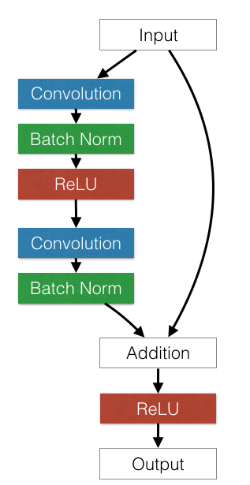Residual Connections:

Deep feed-forward CNN tend to suffer from optimization difficulty. Beyond a certain depth, adding extra layers results in higher training error and higher validation error because a lot of information will be increasingly lost through the deeper neural network, even when batch normalization is used. The residual network architecture solves this by adding shortcut connections that are summed with the output of the convolution layers. The idea of convolutional residual block was produced by the paper [10] titled **“**[**Deep Residual Learning for Image Recognition**](http://arxiv.org/abs/1512.03385)**”**.

Figure ‎2‑4: Convolutional Residual Block.

## Training Details:

### **Dataset:**

In the training process we use Microsoft COCO (Common Objects in Context) dataset which is a large-scale object detection, segmentation, and captioning dataset. COCO dataset has several features:

* It has about 330K images from every day scenes, with more than 200K labeled images.
* And about 1.5 million instances.
* 80 object categories.
* Where there are 5 captions per image.

And, COCO dataset used for several tasks, like image classification, object localization and semantic segmentation. **Fig. 2-5** is an example of what the localization, segmentation and classification mean.

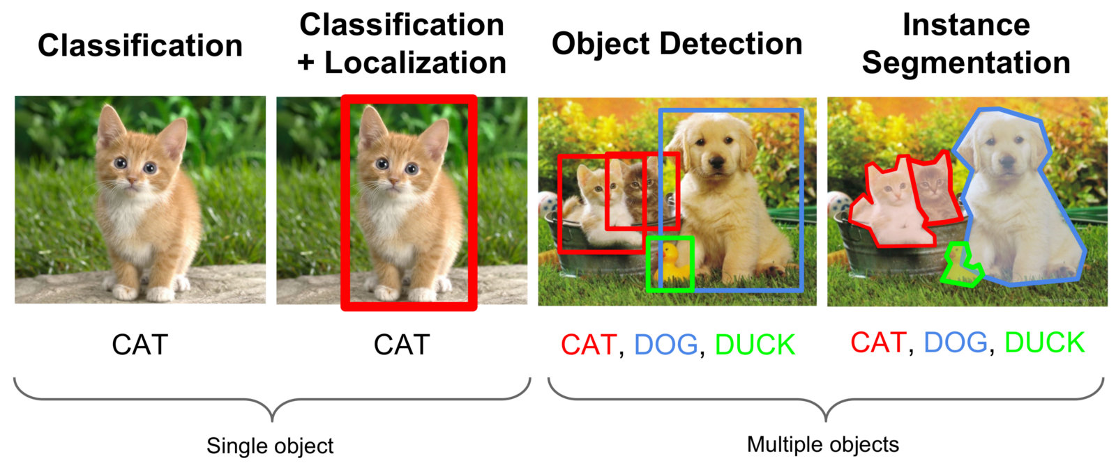

Figure ‎2‑5: Example of classification, segmentation and localization.

### **Training:**

COCO dataset is split into (train/validation/test) sets, we use the training set which contains 83K images with size of 13GB to train our network. We resize the dataset images to 512 × 512 pixels as the input to our model and train our image transformation network with batch size of 1 for 160,000 iterations, giving 2 epochs over the training data. We use Adam optimizer [12] with default learning rate $(1×{10}^{-1})$. And style weight $(λ_{s})$, content weight $(λ_{c})$ and TV weight $(λ_{TV})$ equal to $(3.0)$, $(2.0)$ and $(5×{10}^{-5})$ respectively, and we compute the feature reconstruction loss at layer ‘block4_con2’ and style reconstruction loss at layers ,'block1_conv1', 'block2_conv1', 'block3_conv1', 'block4_conv1' and 'block5_conv1' of the VGG16 network. Our training is done on **Tesla K80 GPU** that is provided by Google [Colaboratory](https://stackoverflow.com/questions/48750199/google-colaboratory-misleading-information-about-its-gpu-only-5-ram-available) where it is a free cloud service for AI developers from google which supports free **GPU**!.

## Codes:

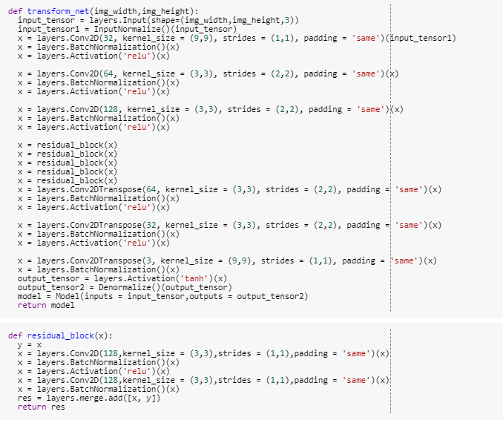

Figure ‎2‑6: Transformation Network

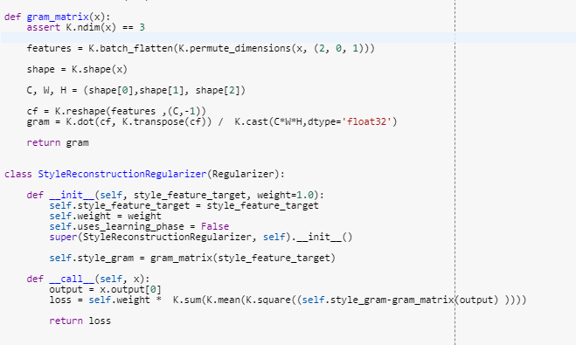

Figure ‎2‑7: Gram Matrix & Style Reconstruction Loss

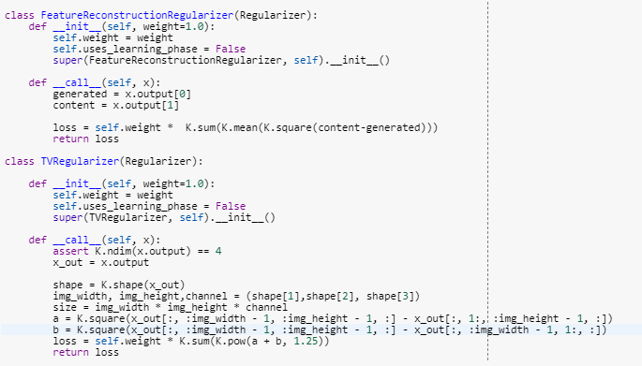

Figure ‎2‑8: Feature & TV Losses

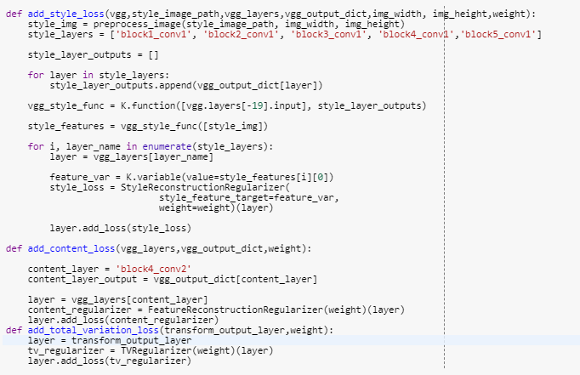

Figure ‎2‑9: Methods to Add the Losses to the Model

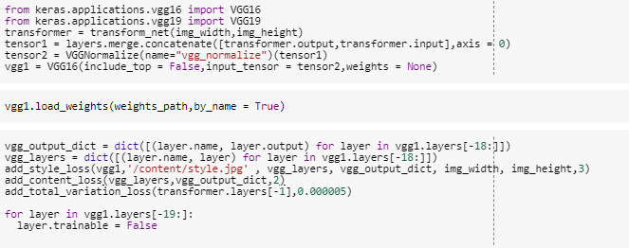

Figure ‎2‑10: Declare & Initialize the Model

# CHAPTER THREE EXPERIMENTS AND RESULT

## Introduction:

We perform some experiments on several style images with different configuration of hyperparameters $(λ_{s} , λ_{c} , λ_{TV})$ and we try to change the contrast of the input images at test time as a preprocess before feed the networks with the input image and we notice that, this preprocess significantly affect the output and make its appearance and style much better than the output image without this preprocess, and here we show you some of our own experiments and results.

## Experiments:

Some experiments to obtain the style and content from different layers using perceptual losses [15][16].

The Style and Content images that were used for this experiment:

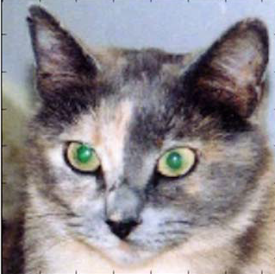**Style Image Content Image**

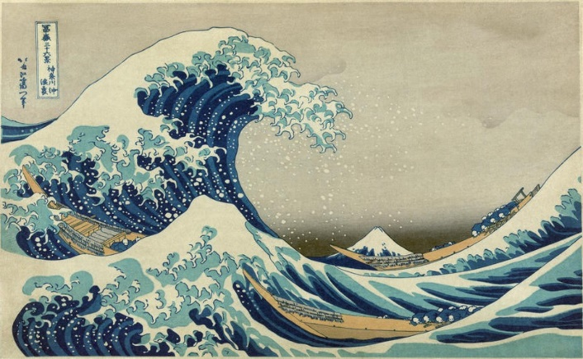

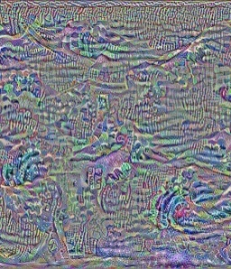Images generated using style loss only from one layer at a time:

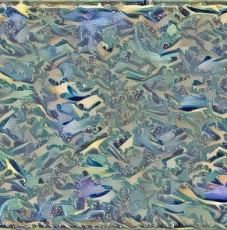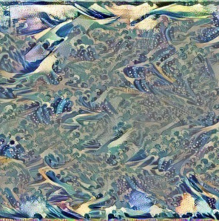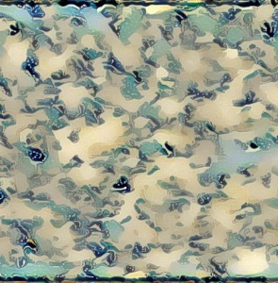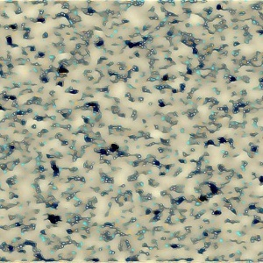 conv1_2 conv2_2 conv3_3 conv4_1 conv5_1

Output of the Content Image at different layers of the feature extraction network:



Figure ‎3‑1: Output at different layers of the feature extraction network

## Results:

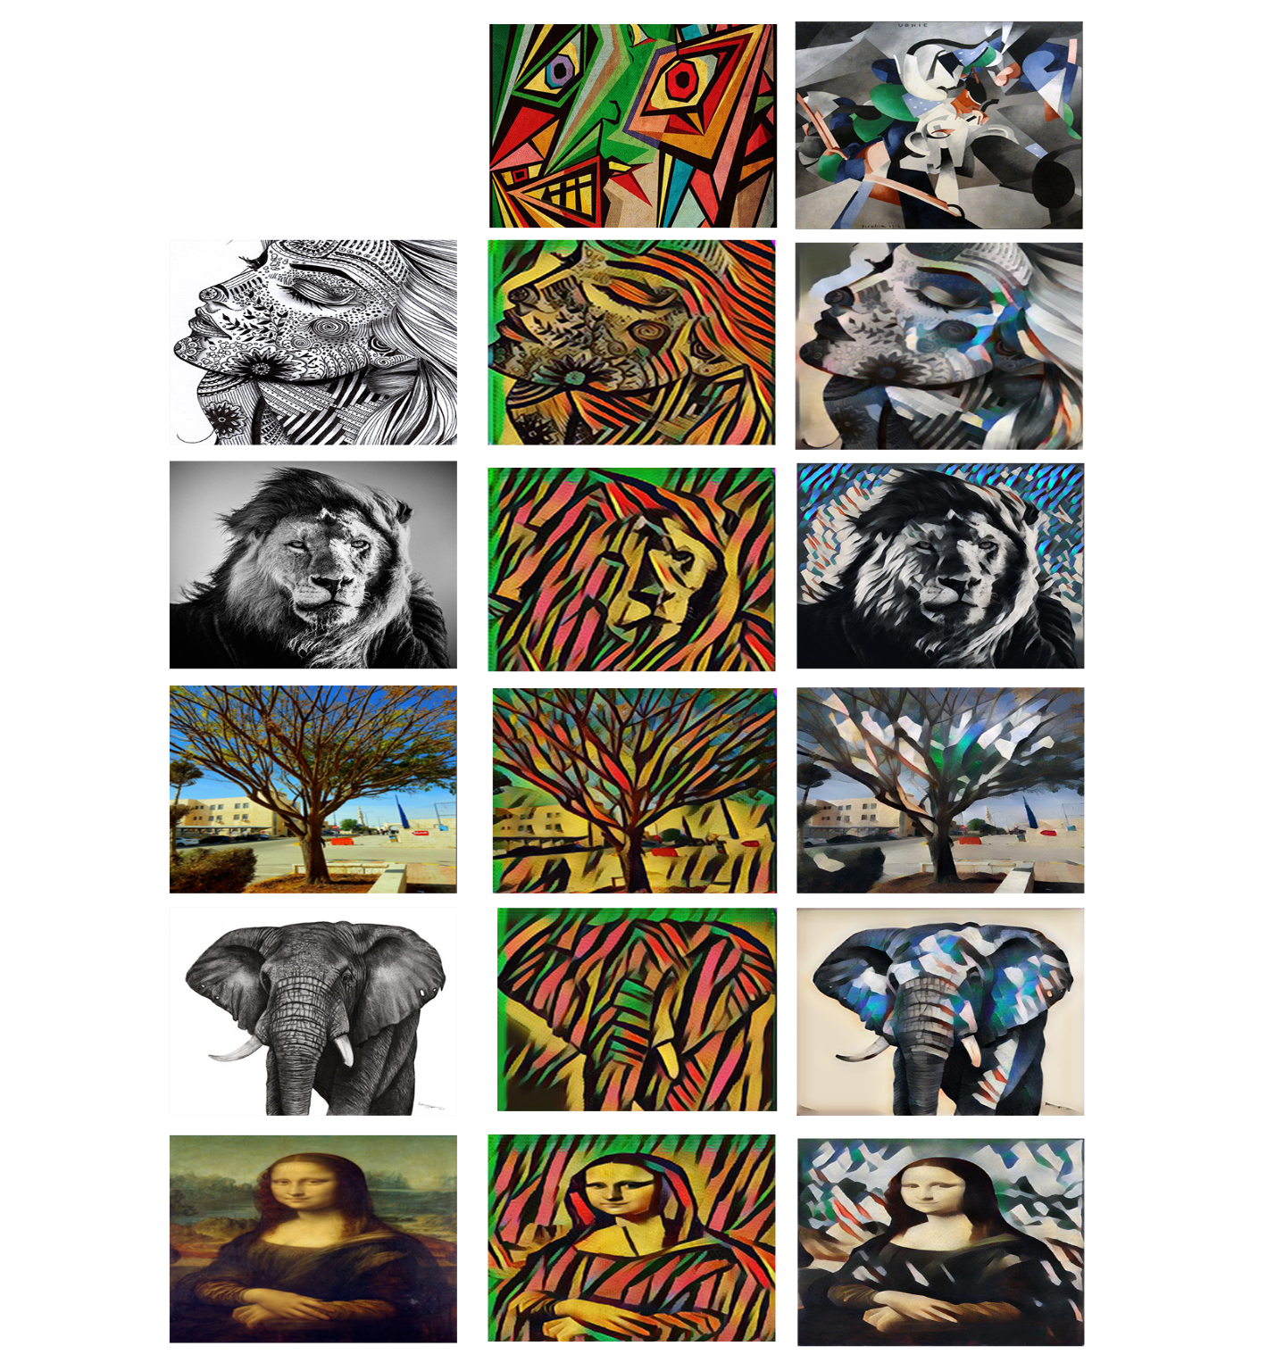We train our Image Transformation Network on different painting art works as style images. And the training process is done on images with size of (512 x 512) pixels, but at test time we feed the network images with size of (1024 x 1024) pixels:

Figure ‎3‑2: Stylized Images Generated by our Model (1)

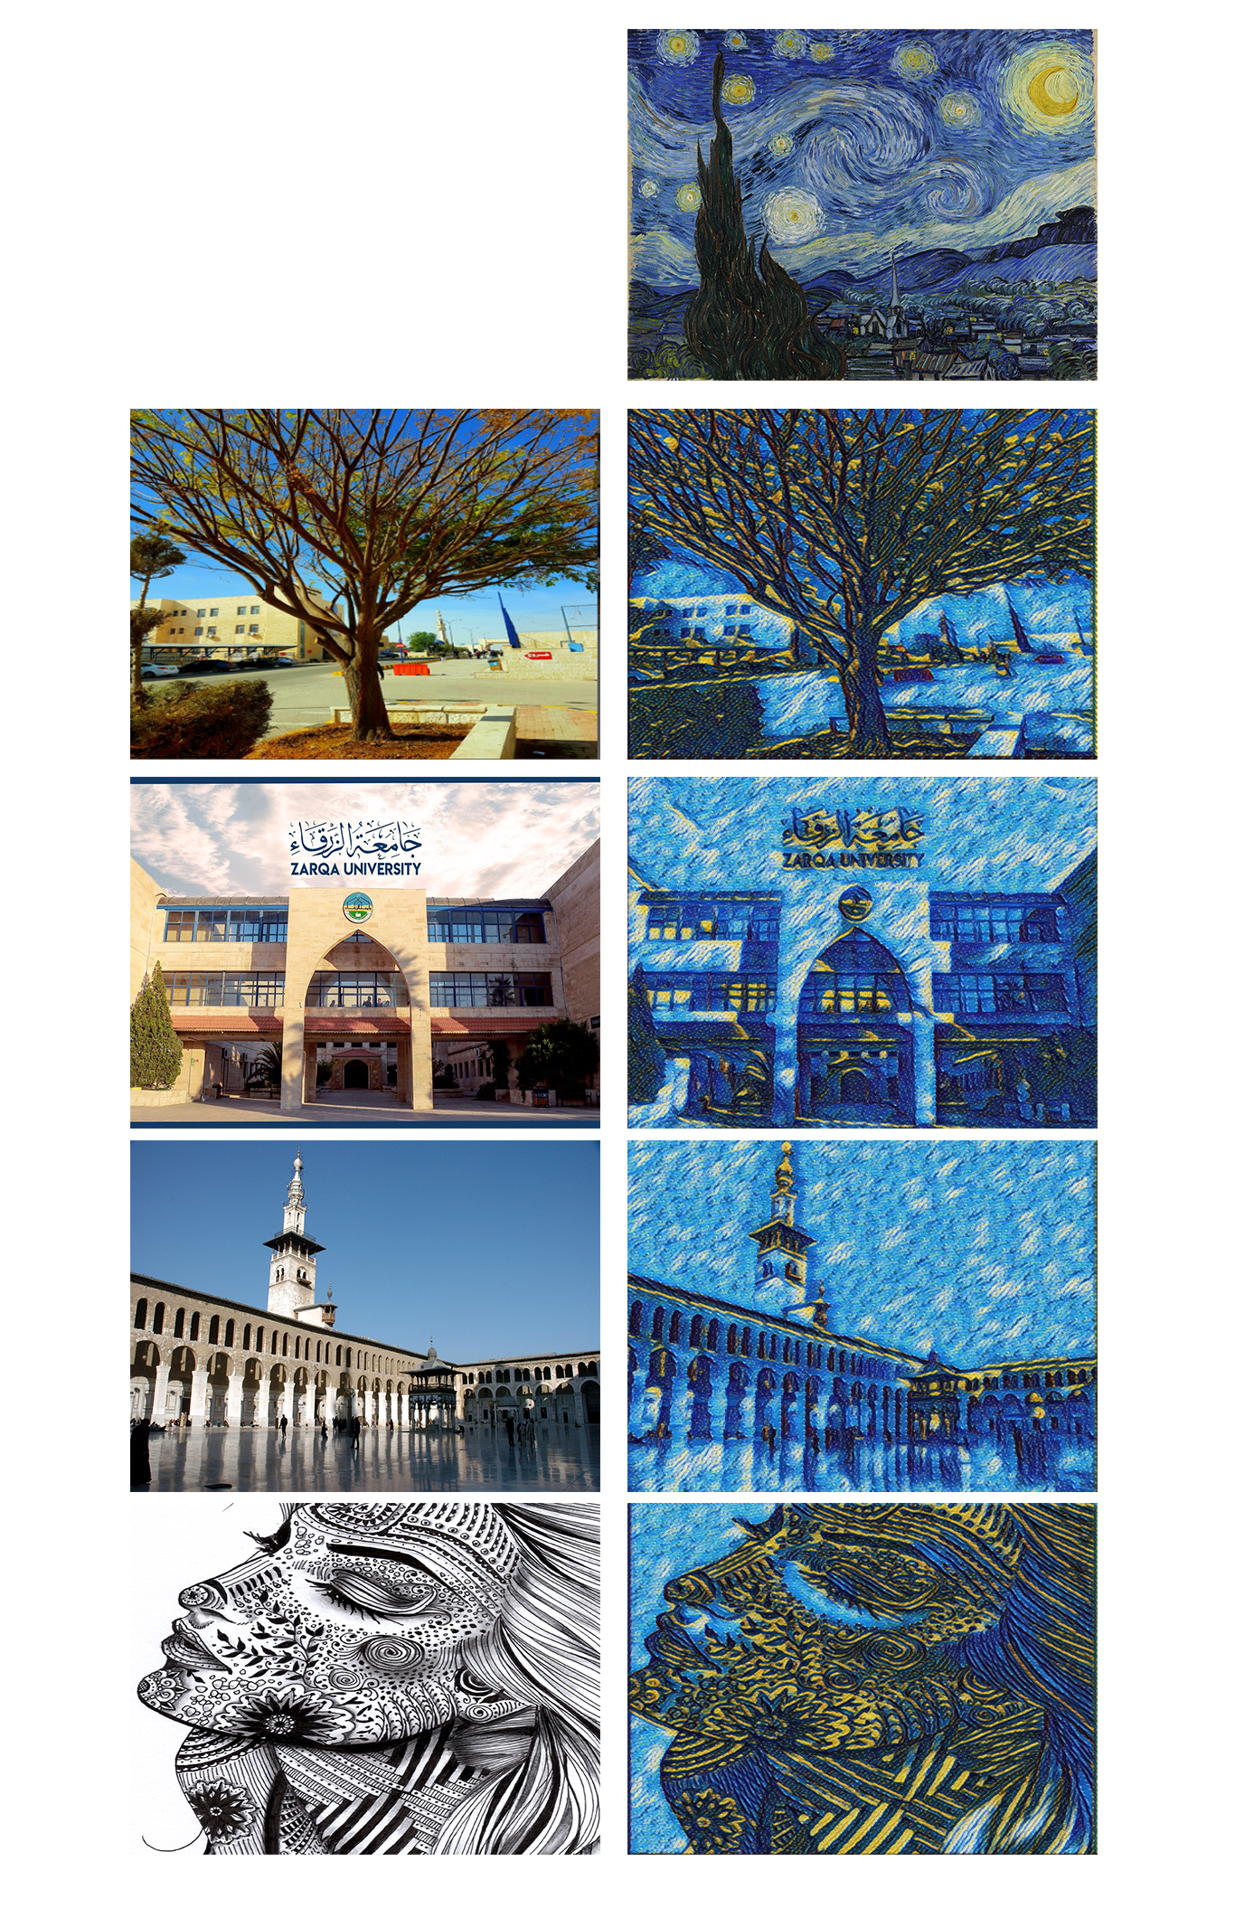

Figure ‎3‑3: Stylized Images Generated by our Model (2)

REFERENCES:

[1] Gatys L., Ecker A., Bethge M.: A Neural Algorithm of Artistic Style, arXiv:1508.06576v2 (2015)

[2] Johnson J., Alahi A. Fei-Fei L.: Perceptual Losses for Real-Time Style Transfer and Super-Resolution, arXiv: 1603.08155 (2016)

[3] Li Y., Fang C., Yang J.: Universal Style Transfer via Feature Transforms, arXiv:1705.08086v2 (2017)

[4] Huang X., Belongie S.: Arbitrary Style Transfer in Real-time with Adaptive Instance Normalization, arXiv:1703.06868v2 (2017)

[5] Simonyan K., Zisserman A.: VERY DEEP CONVOLUTIONAL NETWORKS FOR LARGE-SCALE IMAGE RECOGNITION, arXiv:1409.1556v6 (2015)

[6] Gatys L., Ecker A., Bethge M.: Texture Synthesis Using Convolutional Neural Networks, arXiv:1505.07376v3 (2015)

[7] Lin T., Maire M., Belongie S., Bourdev L., Girshick R., Hays J., Perona P., Ramanan D., Zitnick C., Dollar P.: Microsoft COCO: Common Objects in Context, arXiv:1405.0312v3 (2015)

[8] Radford A., Metz L., Chintala S.: UNSUPERVISED REPRESENTATION LEARNING WITH DEEP CONVOLUTIONAL GENERATIVE ADVERSARIAL NETWORKS, arXiv:1511.06434v2 (2016)

[9] Gross S., Wilber M.: Training and investigating residual nets. http://torch.ch/blog/2016/02/04/resnets.html (2016)

[10] He K., Zhang X., Ren S., Sun J.: Deep residual learning for image recognition, arXiv preprint arXiv:1512.03385 (2015)

[11] Loffe S., Szegedy C.: Batch normalization: Accelerating deep network training by reducing internal covariate shift, arXiv:1502.03167v3 (2015)

[12] Kingma D., Ba J. : Adam: A Method for Stochastic Optimization, arXiv:1412.6980v9 (2017)

[13] Mahendran A., Vedaldi A.: Understanding Deep Image Representations by Inverting Them, arXiv:1412.0035v1 (2014)

[14] d'Angelo E., Alahi A., Vandergheynst P.: Beyond bits: Reconstructing images from local binary descriptors. In: Pattern Recognition (ICPR), 2012 21st International Conference on, IEEE (2012) 935-938

[15] Singla S.: Experiments on different loss configurations for style transfer, https://towardsdatascience.com/experiments-on-different-loss-configurations-for-style-transfer-7e3147eda55e (2017)

[16] Chollet, François.: Deep Learning with Python book, page number (188) (2018)